Telusko: Advance Java 09

201 SpringDataJPA for MulitpleDBconfigruation and Working with Bi Directional mapping

DataJPA
=======
1. Mulitple DBIntegration
2. Association(Bi-Directional)
3. Different type ofJoins
4. SpringMail(demonstration)
=================================
Note::
youtube :: https://www.youtube.com/@najaficode3154
SpringSecurity and Junit with HttpMockito(Notes+videos :: Youtube(Najafi code))
Note: Microservices is not for Freshers
Microservices(From tommo)[Monday would be the last day]
a. Microservices architecture
b. ApacheKafka Intergration
c. RedisCache Integration
d. Hystric circuit breaker
e. EurekaClient and EuerkaServer[StockMarket Application,more attributes of
application.properties]
Multiple DBIntegration
======================
SpringBoot
one Database
In autoconfiguration style, we can make SpringBoot to communicate with Only
Inputs will be supplied through application.properties
a. url
b. username
c. password
d. driver-class-name
e. hibernate specific properties
How to connect with Multiple databases?
only Application - SpringBoot Data Jpa
To connect with Multiple databases, We need to write the code in SpringStyle(Java
Based Configuration)
We need to define below objects(beans) in following order
a. DataSource
b. EntityManagerFactory
c. TransactionManager
by using Spring Java Configuration Style
@Configuration
public class .....{
//no of methods = no of objects
@Bean
public <class/interface> <objName>(){
}
}
Configuration to get a dataSource object for Customer
====================================================
@Configuration@EnableTransactionManagement
@EnableJpaRepositories(
entityManagerFactoryRef = "db1EntityManagerFactory",
transactionManagerRef = "db1TransactionManager",
basePackages = "in.ineuron.repo.customer"
)
public class Db1Config {
// Datasource
@Bean
@ConfigurationProperties(prefix = "db1.datasource")
public DataSource db1DataSource() {
return DataSourceBuilder.create().build();
}
// EntityManagerFactory
@Bean
public LocalContainerEntityManagerFactoryBean
db1EntityManagerFactory(EntityManagerFactoryBuilder emfb) {
HashMap<String, Object> properties = new HashMap<>();
properties.put("hibernate.hbm2ddl.auto", "update");
properties.put("hibernate.dialect",
"org.hibernate.dialect.MySQL8Dialect");
properties.put("hibernate.show_sql", "true");
properties.put("hibernate.format_sql", "true");
return
emfb.dataSource(db1DataSource()).packages("in.ineuron.config.model.customer").prope
rties(properties)
.persistenceUnit("octbatch").build();
}
// TransactionManagement
@Bean
public PlatformTransactionManager db1TransactionManager(
@Qualifier("db1EntityManagerFactory") EntityManagerFactory
factory) {
return new JpaTransactionManager(factory);
}
}
application.properites
======================
db1.datasource.jdbc-url=jdbc:mysql:///octbatch
db1.datasource.username=root
db1.datasource.password=root123
db1.datasource.driver-class-name=com.mysql.cj.jdbc.Driver
db2.datasource.jdbc-url=jdbc:postgresql://localhost:5432/ineuronDb
db2.datasource.username=postgres
db2.datasource.password=root123
db2.datasource.driver-class-name=org.postgresql.Driver
server.port=4444Association in SpringDataJPA
============================
Need of keeping databales in association
=> Keeping multiple entities/items data in single db table
a. Data Redundency Problem(Duplication problem)
b. Data Management Problem(Data Inconsistency Problem)
refer:: .png
Solution1:: keep mulitple entities info in mulitple db tables like user
information in seperate db table and phone number details in
seperate db table
Drawback
=> Now data redundency problem is gone,but datamanagement/navigation problem
is created, we cannot access phone number details
from customer tables records and viceversa
Solution2::Take dbtables to maintain multiple entities info and keep them in
relatioship using FK(ForeignKey Column)
Advantages
=> No Data Redundency Problem
=> No Data Navigation problem,using FK column we canaccess child table
records from parent db table records and vice-versa
If db tables are in relationship then associated entity classes should be taken
having relationship,but we keep db tables in relationship using FK
column where we keep entity class in relationship using Composition and
Collection.
The way dbtables are in relationship is different from the way entity classes in
relationship.
To avoid this mismatching,We use the advanced o-r mapping called "Association
Mapping".
SpringDataJPA supports 4 types of Association
a. One to One
b. One to Many
c. Many to One
d. Many to Many
Association in SpringDataJpa can be implemented in 2 modes
a. UniDirectional Association [ Either Parent to Child or Child to Parent is
accessible]
b. BiDirectional Association [Parent to Child and Child to Parent is
accessible]
Association in SpringDataJpa can be build in Entity class in 2 ways
a. Using Reference type properties in Composition[Non Collection Property]
===> 1 to 1, M to 1
b. Using Collection type properties in Composition ===> 1 to M, M to M
We can keep dbtables either in unidirectional or in bidirectional association
using single FK column, but in java no FK column is available,
so to keep Entity class in association we need to use Composition either collection
or non collection type properties.
Cascading in Association
========================Cascading means, the non select operations performed on the main object will be
propogogated to the Associated object.
public enum CascadeType {
/**
*/
ALL,
/**
*/
PERSIST,
/**
*/
MERGE,
/**
*/
REMOVE,
/**
*/
REFRESH,
/**
*/
DELETE,
* Includes all types listed here.
* Corresponds to {@link javax.persistence.CascadeType#PERSIST}.
* Corresponds to {@link javax.persistence.CascadeType#MERGE}.
* Corresponds to {@link javax.persistence.CascadeType#REMOVE}.
* Corresponds to {@link javax.persistence.CascadeType#REFRESH}.
* Corresponds to the Hibernate native DELETE action.
}

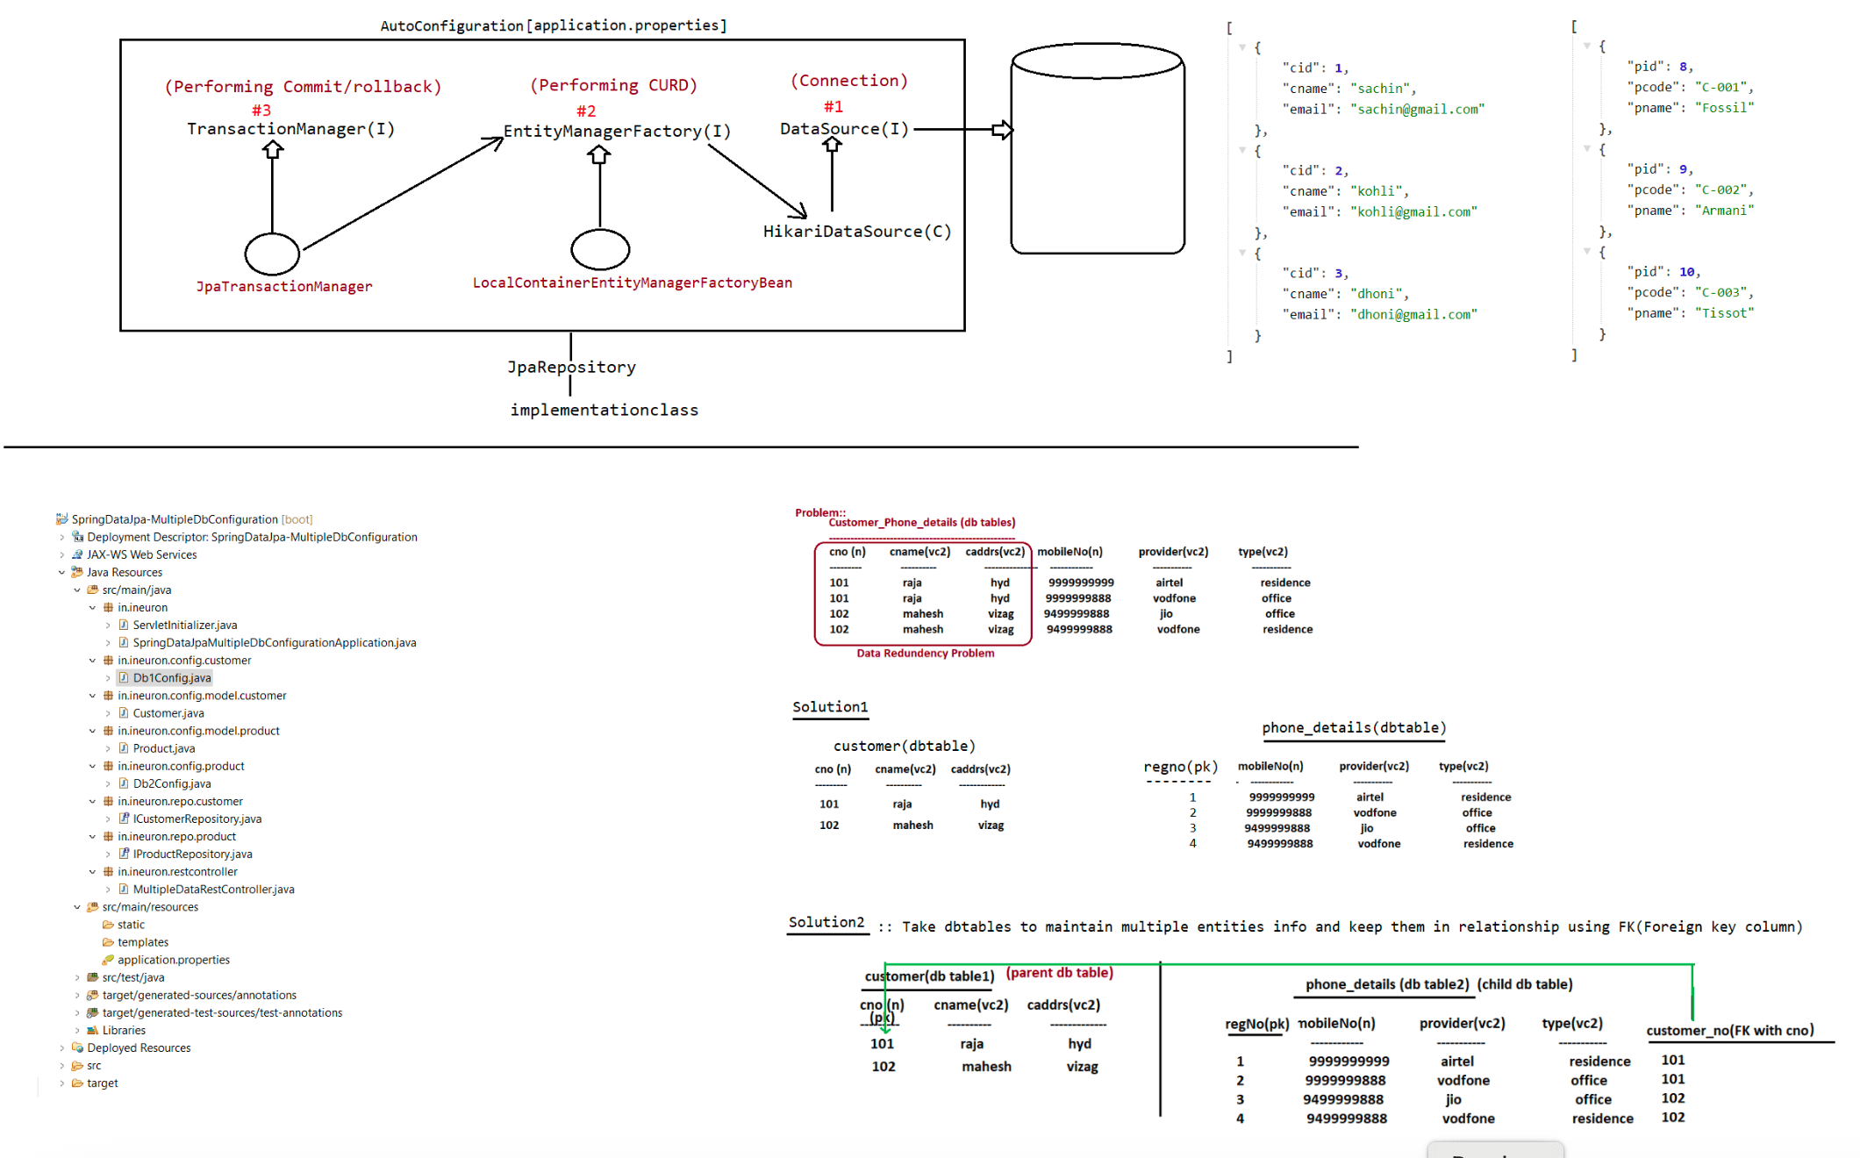

202 SpringDataJPA(Bidirectional mapping and its operation), Executing different types of joins, Usage of cascading and fetchtype

OneToMany-Bi-Directional Mapping
==============================
1. Person.java
@Entity
@Setter
@Getter
@AllArgsConstructor
@Table(name = "OTM_PERSON")
@RequiredArgsConstructor
public class Person {
@Id
@GeneratedValue(strategy = GenerationType.IDENTITY)
private Integer pid;
@NonNull
private String pname;
@NonNull
private String paddress;
@OneToMany(targetEntity = PhoneNumber.class, cascade = CascadeType.ALL)
@JoinColumn(name = "PERSON_ID", referencedColumnName = "pid")
private Set<PhoneNumber> contactDetails;
Person() {
System.out.println("Person 0 param constructor :: " + this.getClass());
}
@Override
public String toString() {
return "Person [pid=" + pid + ", pname=" + pname + ", paddress=" +
paddress + "]";
}
}
2. PhoneNumber.java
@Entity
@Setter
@Getter
@AllArgsConstructor
@Table(name = "OTM_PHONE_NUMBER")
@RequiredArgsConstructor
public class PhoneNumber {
@Id
@GeneratedValue(strategy = GenerationType.IDENTITY)
private Long regNo;
@NonNull
private Long phoneNo;
@NonNull
private String provider;@NonNull
private String type;
@ManyToOne(targetEntity = Person.class, cascade = CascadeType.ALL)
@JoinColumn(name = "PERSON_ID", referencedColumnName = "pid")
private Person person;
@Override
public String toString() {
return "PhoneNumber [regNo=" + regNo + ", phoneNo=" + phoneNo + ",
provider=" + provider + ", type=" + type
+ "]";
}
PhoneNumber() {
+ this.getClass());
System.out.println("PhoneNumber:: Zero param constructor is called ::"
}
}
Note:: In Bi-Directional Association instead of specifying foreign key column using
@JoinColumn in both parent and hild class, we can specify only
at one side with the support of "mappedBy" param.
In OnetoMany Association we need to specify mappedby at Oneside(Parent
class).
class).
In ManytoMany Association we can specify mappedBy at any side(Parent
1. @JoinColumn(name="PERSON_ID",referenceColumnName = "pid")
PERSON_ID
;;;;
2.
@OnetoMany(targetEntity=PhoneNumber.class,cascade=CascadeType.all,mappedBy="person"
)
person_pid
;;;;;
Note:: In Association Mapping the cascading type are related to non-select
operation, which indicates any non-select operation done on main object
will be cascaded/propogated to the associated child objects
In Association Mapping,the fetch types are related to select operation which
indicates the associated child objects should be loaded along with
the Parent objects or not.
FetchType.EAGER => child objects will loaded along with parent
object
FetchType.LAZY => Parent objects will loaded normally,but
associated child objects will be loaded lazily on demand basis.
=> Default fetch type for OnetoMany,OnetoOne,ManytoMany Association :: LAZY
=> Defalut fetch type for Many to One Association :: EAGER
Delete Operation in Association Mapping
======================================
Delete Parent object, so Deletion of Child object also should happen.
Delete child object, but parent object should not be deleted.Joins
=====
=> Joins are given to get data from two db table of association having some
implicit condition
=> We can also add new condition on top of implicit condition
=> In SQL to work with joins the two db table need not be in relationship, whereas
in HQL/JPQL the two dbtalbles needs to be in association to apply joins
=> To work with HQL/JPQL we need to keep dbtables and their entity class in
relationship using association mapping concepts.
Syntax::
select <parent class propertiye>,<child class properties> from <parent
class><alias name>
<join type> <parent class HAS-A property>
<aliasname> <additional condition>
IPersonRepo.java
================
public interface IPersonRepo extends JpaRepository<Person, Integer>{
//@Query("select
p.pid,p.pname,p.paddress,ph.regNo,ph.phoneNo,ph.provider,ph.type from Person p
inner join p.contactDetails ph")
//@Query("select
p.pid,p.pname,p.paddress,ph.regNo,ph.phoneNo,ph.provider,ph.type from Person p
right join p.contactDetails ph")
//@Query("select
p.pid,p.pname,p.paddress,ph.regNo,ph.phoneNo,ph.provider,ph.type from Person p
left join p.contactDetails ph")
@Query("select
p.pid,p.pname,p.paddress,ph.regNo,ph.phoneNo,ph.provider,ph.type from Person p
full join p.contactDetails ph")//Error
public List<Object[]> fetchDataUsingJoinsByParent();
}
AssociationRunner.java
======================
@Component
public class AssociationRunner implements CommandLineRunner {
@Autowired
private IPersonMgmtService service;
@Override
public void run(String... args) throws Exception {
service.fetchDataByJoinsUsingParent().forEach(row->{
for (Object obj : row) {
System.out.print(obj+" ");
}
System.out.println();
});
}
}

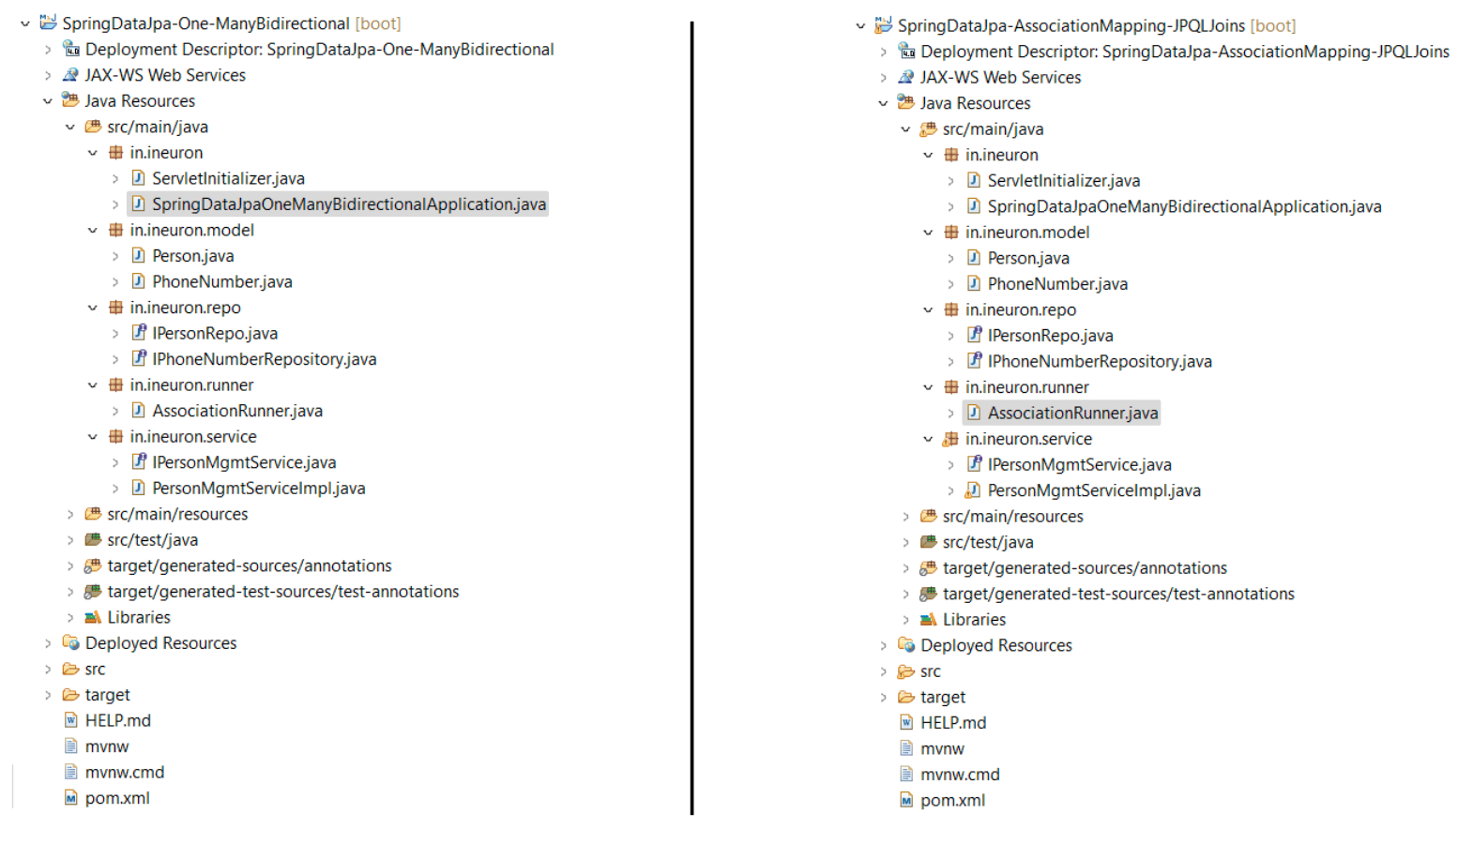

203 SpringBoot+Mail intergration, Introduction to microservices, usage of Monolothic vs Microservices architecture.

Sending Email using Spring Boot
===============================
Steps to develop Spring boot application to send Email
1. Create spring boot application with below dependancies
a. spring-boot-starter-web
b. spring-boot-starter-mail
2. Configure below properties
server.port
smtp properties
note: Here we are using gmail SMTP properties for practise purpose,In company they
will share SMTP properites for use.
3. Enable Less Secure Apps for the mail which is configure in SMTP properties for
Authentication.
1. Enable 2 step verification
2. Open 2 step verification page, go to the bottom and Click on
App passwords.
3. Generate app password with type as ‘Others’(copy the password
and keep in applicatin.properties)
4. Create EmailService Class with the required methods to send mail(we will use
Spring Provided JavaMailSender to send emails)
5. Create RestController method to accept the request(This method will call
EmailService class method to send mail)
6. Run boot application and Test it.
application.properties
======================
#Properties to tell the mail protocol vendor
spring.mail.host=smtp.gmail.com
spring.mail.port=587
#Actual username,password of sender
spring.mail.username=username
spring.mail.password=(password generated)
#Property to trigger smtp
spring.mail.properties.mail.smtp.auth=false
spring.mail.properties.mail.smtp.starttls.enable=true
spring.mail.properties.mail.smtp.starttls.required = true
refer:: SpringBoot-MailApp
Microservices
=============
Monolith Architecure
In our application,we will have several modules and several components are also
available.Components are
a. Presentation Components
-> These are responsible for handling HttpRequests.
-> Webapplications means front end pages,Distrubuted applications
means RestClients.
b. Web Components
-> Responsible to handle user requests.(Servlets basically
handles the Requests).
c. Business Components
-> Responsible to handle the buisness logic as per the buisness
deals.
d. Persistence Components
-> DAO is responsible for performing DB operations like
DML,DDL,TCL,....
e. Integration Components(Webservices,RestFul Services)
-> Two projects can talk to each other only when we have
Integration logic(basically RestfulServices,WebServices,...).
f. Authorization Components
-> Responsible for Authorizing the user.
g. Notification Components
-> Responsible for sending email or mobile msgs notifications.
If we develop all these components as a single project then it is called as
"Monolith Architecture".
refer : MonolithArchitecure.png
Benefits of going for Monolith Architecure
==========================================
1. Simple for development(becoz all are available in single project): At initial
time it is very easy.
2. Easy for Testing : End to End Testing we can perform.
3. Easy for deployment : One war file only we have to deploy to server.
4. Easy for Scaling : multiple server we can spin easily(hortizontal/vertical
scaling)
if requests increases then we can make keep
multiple servers through which the scaling can be done to provide
good responses to the client.
DisAdvantages of Monolith Architecture
=====================================
1. Maintainence of the application:
If the application is to large and complex,it is
difficult to understand.
Change Request in the code is very
difficult.
Some changes in the existing application
will have an impact to the other code,
Lot of Impact Anaylsis will occur.
2. Adapting to NewTechnology is required: Change in java version and adapting to
the version change also will take time.
Application start up will take
more time becoz it is a fatty war file.
3. Relaibility : If one components has a bug, it leads to application bug and
entire application will go down.4. If we make some changes to the code, we need to redeploy the entire
application to the server which is time consuming.
5. Adpating to new version of framework and releasing the quick release is very
difficult.
6. New Team members can't understand the project easily because of lack of Impact
anaylis and less exposure to project.
To resolve the above mentioned disadvantages we need to opt for an Architecutre
called "Microservices".
LoadBalancers and LoadBalancers Algorithms
==========================================
-> When all components are in same applications, all request comes to same servers
then burden will increase on the same server.
-> More the requests to the server, then the performance at the server side will be
slow so the response time is high for clients.
eg: youtube,myntra,flipkart,.......(laksh of users will send the
request still the response time will be uniform for client)
-> when burden increased on server it will process the request slowly and some
times the server might crash also.
-> To reduce the burden on the server, people use LoadBalancer for the
applications.
=> LoadBalancer uses LoadBalancing algorithms to balance the load.
=> Our applications will be deployed in multiple servers and those servers will be
connected to LoadBalancer.
How LoadBalancer will distribute the load?
LoadBalancer will use LoadBalancer Algorithms to distrubute incoming request 2
servers.
Algorithms
==========
a. Round Robin
=> In RoundRobin fashion the request will be processed in round
robin ways(1,2,3, and again it repeats)
b. Sticky Session
=> Based on session object details stored in the server the
balancing will happen.
c. IP Hashing
=> By implementing one formula on the server side,
serverNo=hash(IP) the balancing will be done on the LoadBalancer.
What is Microservices?
MicroServices is not a technology or a framework or not an API.
It is an Architectural Design pattern.(just like singleton pattern,factory
design pattern,strategy design pattern)
Microservice design pattern came into market to avoid the problems of monolithic
architecture.
If we compare the microservices architecture with the other design patterns we
get to know the benefits of Microservices.
refer: monolitich(load balancer).png
microservicearchitecture.png
monolitich vs mircoservices.png
SAGE pattern.pngWhat are the challenges which will be faced by the developers if we are following
microservices design pattern in our project?
a. Bounded context
b. Lot of configuration
c. Less visibility
d. Pack of Cards Problem

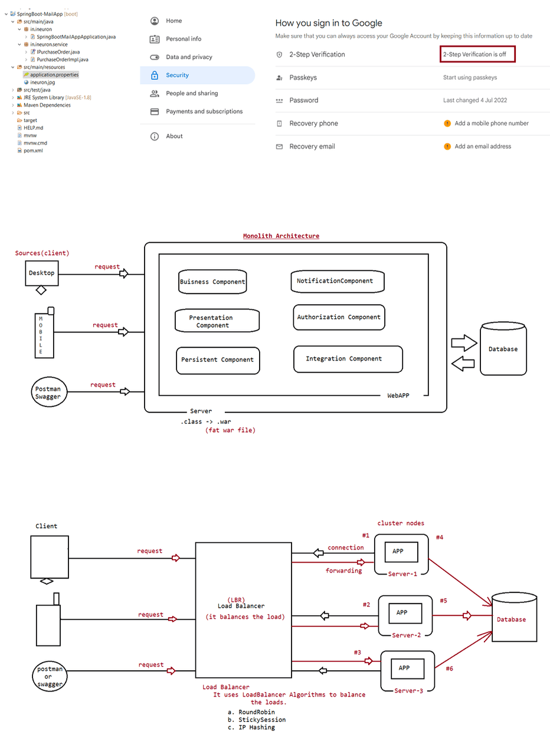
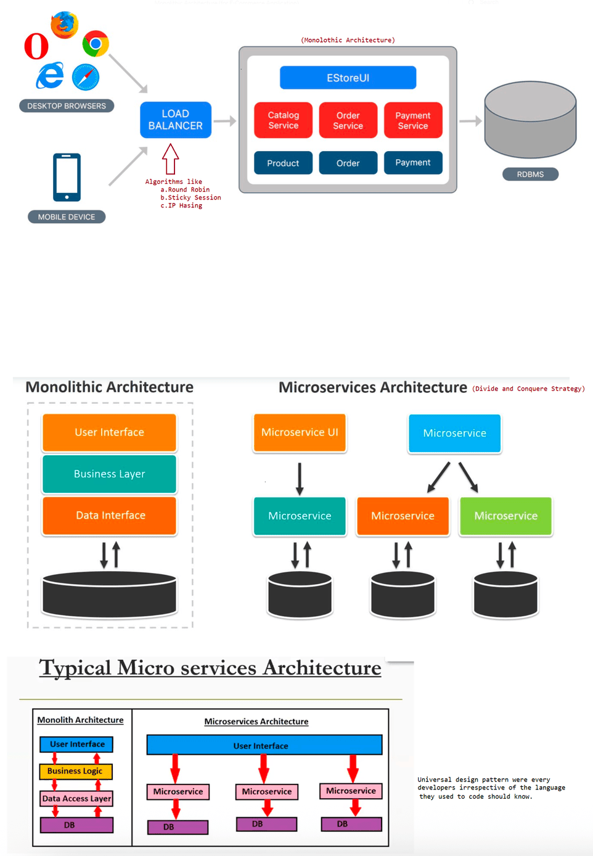

204 Microservice Architecuture,Challenges of Microservices,FeignClient, StockAPI Project

Pre-Requisite
=============
SpringBoot
SpringRest(SpringMVC++)
SpringDataJPA(Working with MySQL,Embeded database(h2))
SpringAOP
Build Project using Monolothic Style
Microservices
=============
What are the challenges which will be faced by the developers if we are following
microservices design pattern in our project?
a. Bounded context
b. Lot of configuration
c. Less visibility
d. Pack of Cards Problem
a. Bounded context
It is difficult to decide the boundary for one microservices.
boundary -> which functionality should be devleoped as a seperate
project(microservices) is very challenging.
b. Lot of configuration
In microservices architecture we develop mulitple projects or multiple
services, so for every service we need to give configuration
like DB config, Actuator Config,SMTP config,logging config, Kafka
configuration, etc,...
c. Less visibility
All the team members may not get the chance to work with all
microservices, so they will not have complete clarity on the project.
note: Mulitple microservices will be divided into multiple
teams(BNG,CHENNAI,HYD,....)
d. Pack of Cards Problem
If any main microservice is failed, then the dependent microservices is
going to fail, so it is not possible to process the request.
refer: Challenges of Microservices.png
Advantages of Microservices
===========================
1. Easy maintainence(only few requirements are developed as single project becoz
we follow divide and conquer strategy)
2. Faster releases => As we are developing limited functionality very quickly we
can complete development and testing and we can release microservices.
3. Parallel development => Multiple teams can work with Multiple microservices
parallely if there is no dependency which reduces the development time.
4. Adopting to new technology(Cross platform(developing Microservices in
different language))
=> There is no rule saying that all Microservices should be implemented
in same programming language.
=> We can use different technology to develop different microservices.
5. Easy Scaling => We can scale our microservices based project easily(improving
the capacity of the servers)Microservices Architecture
==========================
Note : There is no fixed Microservices Architecture, they would be using as per
their comfort and requirement.
Generalized Microservice Architecture
=====================================
Most of the developers follow this architecture to develop the projects.
MicroServices Architecture Components
a. Service Registry(Eureka Server)
b. Micro-Services (RestApi's)
c. API Gateway(Zuul proxy)
What is Service Registry?
=> Registry(just like school teacher maintaining the register)
=> Service Registry is used to register services(API's) available in our
projects.
=> It provides the dash board with services information like
a. status
b. health
c. URL etc,...
=> Service means one ReST api.
eg: Assume there are 70 services in a project, so we can keep track of
those services in "Service Registry".
=> We can use Eureka Server as a "Service Registry".
What is Services?
One Service is called as "RestApi".
ReST API's are called as "Services in microservices based project".
ReST API's contains buisness logic to perform buisness operations.
As part of Buisness operation, One ReST Api can communicate with another ReST
Api.
Microservice architecture means collection of ReSTApi's.
What is API Gateway?
An API Gateway is an API management tool that sits b/w client and collection of
back end services(RestApi's).
API Gateway acts as single entry point for all clients.
In API Gateway we can write the logic to filter the user request.
eg: Zuul proxy.
refer: MicroService Architecture.png
How to register with Eureka Server?
Service Registry is used to register all services available in the
project(RestApi's).
What is the advantages of register the services in Eureka Server?
If we register the services, then in the Service Registery DashBoard we would get
to know the name of the service,health of the services,
URL of the Services,....
Eurekha Server is been used as Service Registery.
Eurekha Server is runing on 8761 then Discovery clients can auto register with
Eureka Server.Developing the Eurekha Server(default port no : 8761)
=====================================================
Create a Spring boot with the following dependecies
a. spring-boot-starter-web
b. spring-cloud-netflix-eureka-server
use the following annotations
a. @EnableEurekaServer at boot start class to indicate it as Eurkeha Server
class
Make the following changes in application.properties file
eureka.client.registerWithEureka = false
eureka.client.fetchRegistry = false
server.port = 8761
run the application, open the browser and type as http://localhost:8761 eureka server DashBoard
to see
pom.xml
=======
<dependency>
<groupId>org.springframework.boot</groupId>
<artifactId>spring-boot-starter-web</artifactId>
</dependency>
<dependency>
<groupId>org.springframework.cloud</groupId>
<artifactId>spring-cloud-starter-netflix-eureka-server</artifactId>
</dependency>
Develop First Service as Eurekha client
=======================================
Create a Spring boot with the following dependecies
a. spring-boot-starter-web
b. spring-cloud-netflix-eureka-client
use the following annotations
a. @EnableDiscoveryClient at boot start class
Create RestController with the requried methods
Configure embeded container port no and application name
Run our application.
Verify Eurekha Server DashBoard(client should be registered)
Develop Second Service as Eureka Client
=======================================
Create a Spring boot with the following dependecies
a. spring-boot-starter-web
b. spring-cloud-netflix-eureka-client
use the following annotations
a. @EnableDiscoveryClient at boot start class
Create RestController with the requried methods
Configure embeded container port no and application name
Run our application.
Verify Eurekha Server DashBoard(client should be registered)Note: Before running client application, make sure Eurekha server project is
running
If v want 2 change the port no of eurekha server,we use d following code
a. Service-Register-Eurekha-Server
application.properties
======================
eureka.client.registerWithEureka = false
eureka.client.fetchRegistry = false
server.port = 9761
b. Eurekha-Client-HI-Service
application.properties
======================
server.port=9999
spring.application.name=HI-SERVICE
eureka.client.service-url.defaultZone = ${DISCOVERY_URL:
http://localhost:9761}/eureka/
Now run server first by typing the url
http://localhost:9761/
Now run client by typing the url
http://localhost:9999/
We have Created 3 Applications
a. Service-Registry (PortNO: 9761)
b. HI-SERVICE(PortNo: 1111 Eurekha Client-1)
c. HELLO-SERVICE(PortNo: 2222 Eurekha Client-2)
InterService Communication
==========================
In our project, if one microservice wants to communicate with another microservice
then it is called as "Inter Service Communication".
Note: Both microservice belongs to same project.
=> We can use RestClient logic to access one Rest Api.
eg: RestTemplate,WebClient,...
=> Feign client will be used if both microservices belongs to same project.
=> Advnatages of Feign Client is we can specify the "service name" not the URL.
Dependencies of Feign Client
============================
pom.xml
=======
<dependency>
<groupId>org.springframework.cloud</groupId>
<artifactId>spring-cloud-starter-openfeign</artifactId></dependency>
code
====
#1.
package in.ineuron.client;
import org.springframework.cloud.openfeign.FeignClient;
@FeignClient(name = "HELLO-SERVICE") // name is recomended over URL(becoz the URL
will change when we opt for load balancer)
public interface HelloClient {
@GetMapping("/hello/{name}")
public String invokeHelloService(@PathVariable String name);
}
Note: Through name we are not writing URL, so through service registry the services
are loosely coupled.

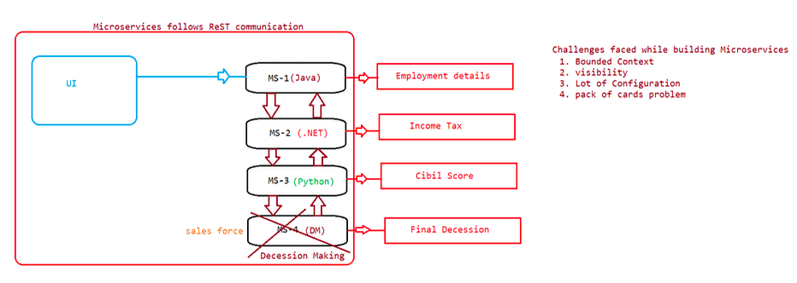
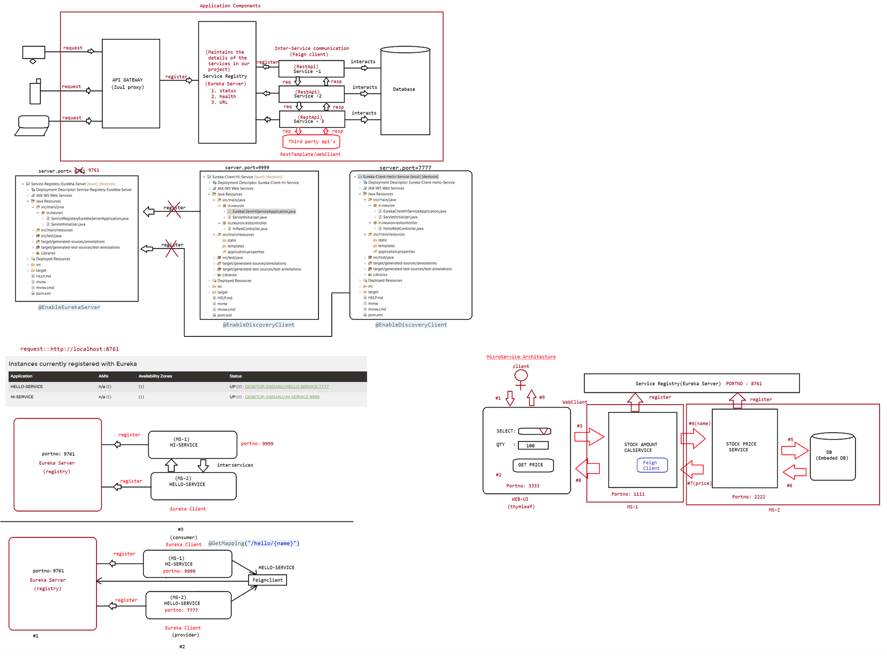
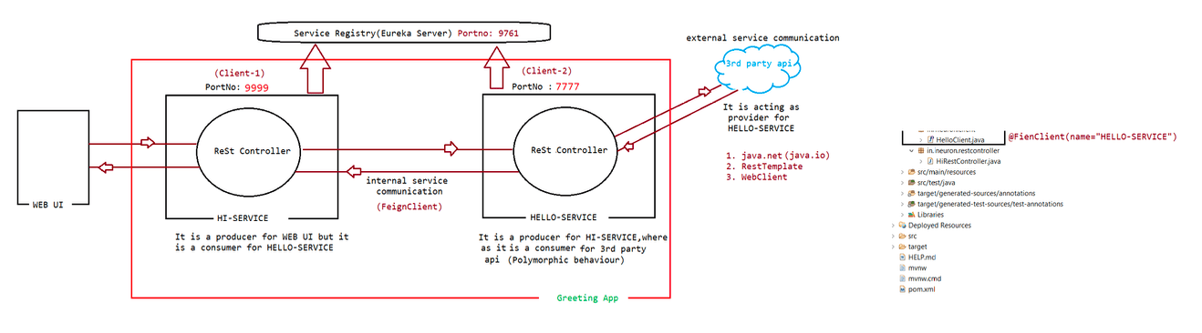

206 Microservices project integration of mulitple microservices,actuators

Today Topic
===========
1. StockProject(Using MS)
2. Api-Gateway(ZuulProxy Server)
3. Actuators
4. SpringBoot-AdminDashboard(To manages the services)
Topics Left
===========
Monday topics::
1. Circuit Breaker[hystrik-circuit-breaker]
2. MessageBroker[Apache-Kafka]
Tuesday topics::
3. RedisCache
4. ReactiveProgramming
Video part:: SpringSecurity and Junit with Mockito(will uploaded in dashboard)
refer::
Service-Registery-Eurekha-Server
Stock-Calcuation
Stock-Service
Stock-UI-APP
APIGateway
=========
It acts as entry point for all microservices in our project.
It is also called as "Edge Microservice".
If we don't have APIGateway, then we need to implement request filtering logic in
every microservice,it increases the maintainence cost of the project.
Zuul Proxy we can use as "APIGateway",it is provided by spring-cloud-netflix
library.
It is an open source gateway.
Apigee is a commercial APIGateway provided by google.
Steps to develop API Gateway
============================
1. Create spring boot application with below dependancies
a. spring-boot-starter-web
b. spring-cloud-netflix-zuul
c. spring-cloud-netflix-eurekha-client
2. Configure @EnableZuulProxy and @EnableDiscoveryClient annotations at spring boot
starter class
3. Configure API gateway with Eurekha server registration
4. Configure Routing to access backend services 5. Configure ApplicationName and port no.
in application.properties/yml file
application.properties
======================
server.port= 4444
spring.application.name=STOCK-API-GATEWAY
zuul.prefix=/api
zuul.routes.price.path=/price/**zuul.routes.price.service-id==STOCK-PRICE-SERVICE
zuul.routes.calc.path=/calc/**
zuul.routes.calc.service-id==STOCK-CALCUlATION-SERVICE
StockApplication using Microservice Architecture
================================================
ServiceRegistry: http://localhost:8761
STOCK-PRICE-SERVICE: http://localhost:1111/price/stockprice/{companyName}
STOCK-CALC-SERVICE: http://localhost:2222/calc/calculate/{companyName}/{quantity}
API-GATEWAY : http://localhost:4444/api/
URL's given to end user
=======================
To get company price :
http://localhost:4444/api/price/price/stockPrice/{companyName}
To get total cost :
http://localhost:4444/api/calc/calc/calculate/{companyName}/{quantity}
Actuators
=========
=> We are developing our applications using springboot and those applications will
be deployed in servers.
=> After deploying our applications in server, those applciation will be used by
the clients(users).
=> when our application is running in production, It is very important to monitor
the application.
=> Monitoring the application corresponds to how the application is responding the
clients.
What is the meaning of Monitoring the application?
a. HealthCheck
b. BeansCheck[Gettign to know all the beans available for MS]
c. configProps check[Getting to know all the END_POINTS]
d. Headump
e. Thread dump(information about threads)
f. Http trace etc.....
=> To monitor our applications,Spring boot has provided actuators.
=> Actuators are used to provide "Production ready features" of our application.
Working with actuators
======================
1. use the following dependancies in our application
<dependency>
<groupId>org.springframework.boot</groupId>
<artifactId>spring-boot-starter-actuator</artifactId>
</dependency>
2. Actuators provided several predefined endpoints to monitor our application
a. health
b. info
d. heapdump
c. beans[To know all the beans loaded in our application]e. Threaddump
f. shutdown(It is a special endpoints)
g. configProps
h. mappings[To know all the url patterns of our application]
3. To access actuator endpoints we should use /actuator as prefix(It is introduced
from SpringBoot2.X)
eg: http://localhost:9999/actuator/health
4. In SpringBoot 1.x 'actuator' is optional in URL to access the endpoints.
5. In SpringBoot 2.x 'autuator' is compulsory in URL to access the endpoints.
6. By default 2 endpoints will be available(health,info)
Note: In order to include all the inbuilt endpoints
management.endpoints.web.exposure.include=*
management.endpoints.web.exposure.exclude=health,mappings,beans
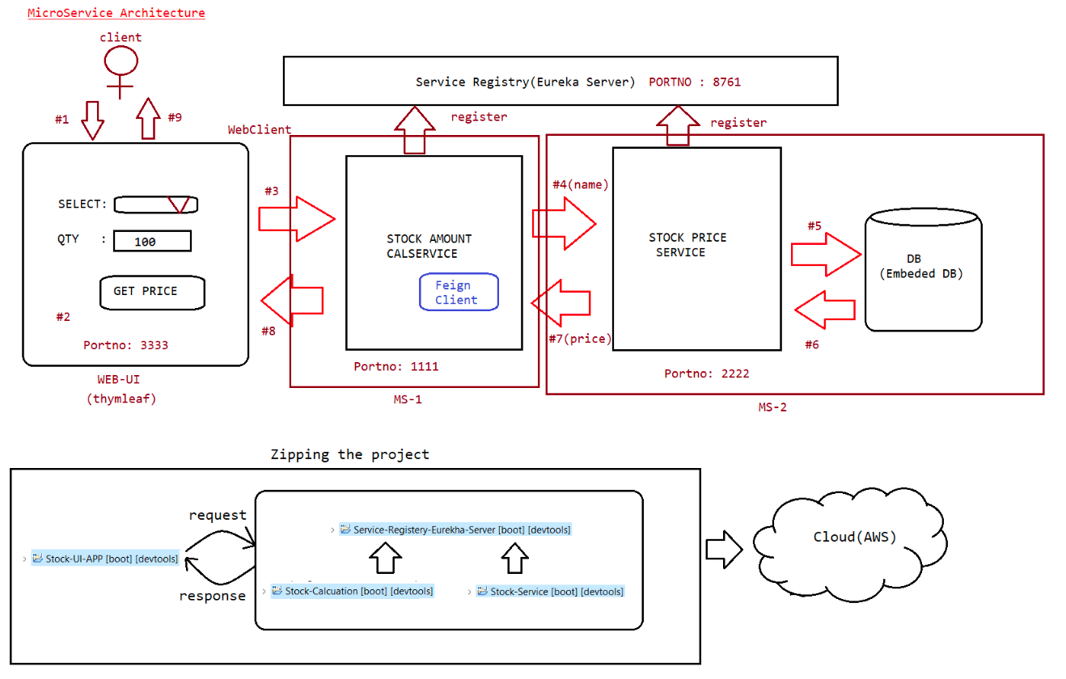
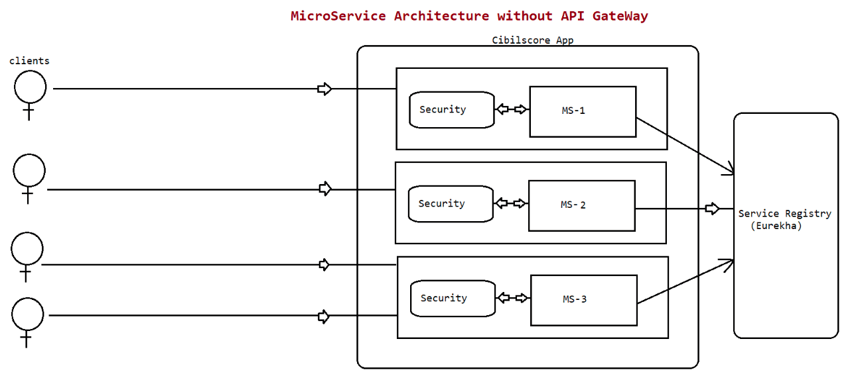
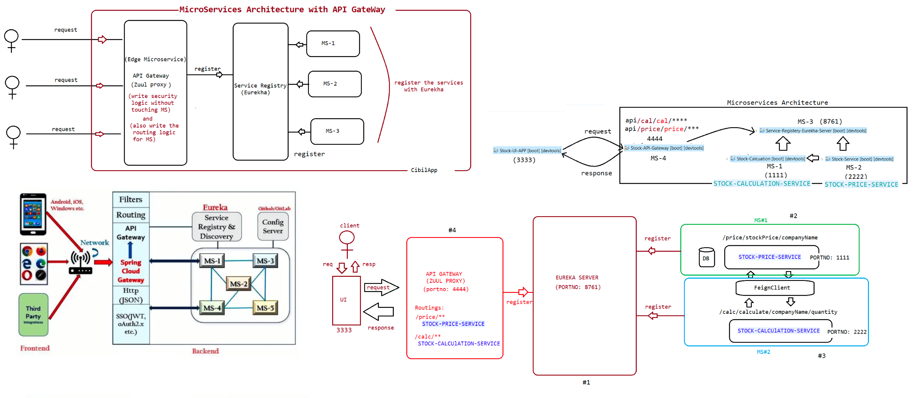

207 Live

Profiles in SpringBoot :: 6thApril video
Video topic: SpringSecurity and Junit with Mockito(Will be uploaded soon)
Today Evening Topic:
a. CloudConfig server(springprofiles)
b. CircuitBreaker(hsytrix circuit breaker)
c. Distubuted logging in Microservices
Tommo Last session
a. Morning Sesion[RedisCache integration]
b. Evening Session[Webflux:ReactiveProgramming]
c. Apache-Kafka Integration
Actuators
=========
=> We are developing our applications using springboot and those applications will
be deployed in servers.
=> After deploying our applications in server, those applciation will be used by
the clients(users).
=> when our application is running in production, It is very important to monitor
the application.
=> Monitoring the application corresponds to how the application is responding the
clients,
What is the meaning of Monitoring the application?
a. HealthCheck
b. BeansCheck
c. configProps check
d. Heap dump
e. Thread dump(information about threads)
f. Http trace etc.....
To monitor our applications,Spring boot has provided actuators.
Actuators are used to provide "Production ready features" of our application.
Working with actuators
======================
1. use the following dependancies in our application
<dependency>
<groupId>org.springframework.boot</groupId>
<artifactId>spring-boot-starter-actuator</artifactId>
</dependency>
2. Actuators provided several predefined endpoints to monitor our application
a. health
b. info
c. beans[To know all the beans loaded in our application]
d. heapdump
e. Threaddump
f. shutdown(It is a special endpoints)
g. configProps
h. mappings[To know all the url patterns of our application]
3. To access actuator endpoints we should use /actuator as prefix(It is introduced
from SpringBoot2.X)
eg: http://localhost:9999/actuator/health4. In SpringBoot 1.x 'actuator' is optional in URL to access the endpoints.
5. In SpringBoot 2.x 'autuator' is compulsory in URL to access the endpoints.
6. By default 1 endpoints will be available(health)
Note: In order to include all the inbuilt endpoints
management.endpoints.web.exposure.include=*
management.endpoints.web.exposure.exclude=health,mappings,beans
heapdump => It is used to download heap details, To analyse heapdump we use
analyzer tools called MAT[Memory Analyzer Tool].
threaddump => It is used to give information about the threads available in our
application.
shutdown
========
It is a special endpoint.
It is used to stop the application.
This endpoint by default is in disable state.
This endpoint is binded to HTTPPOST request method(we can send the request from
browser due to security reasons)
management.endpoint.shutdown.enabled=true
For any application we can send the request in the following ways
POST => http://localhost:9999/actuator/shutdown application would be shutdown
in postman tool then the
|
|
|output
{
"message": "Shutting down, bye..."
}
SpringBoot Admin Server and Admin Client
========================================
In Microservices architecture based project, we will have several services they
are RestApi's.
To monitor RestApi's we will enable and expose actuators endpoints
If we have more no of services, it will be difficult to monitor and manage all
our services.
To overcome this problem,SpringBoot has provided "Admin Server" and "AdminClient"
concept.
If we use Admin Server,it will provide beautiful user interface to monitor and
manage our RestApi's.
Note: Our RestApi's should be register with Admin Server then our RestApi's is
called "Admin Client".
Steps to create AdminServer for our application
===============================================
1. Create a SpringBoot application with the following dependencies
a. spring-boot-starter-web
b. spring-boot-starter-admin-server
2. Configure @EnableAdminServer in SpringBoot starter class
3. Configure embeded container port not in application.properties/yml file4. Run application
Steps to create AdminClient for our application
================================================
1. Create a SpringBoot application with the following dependencies
a. spring-boot-starter-web
b. spring-boot-starter-admin-client
c. spring-boot-starter-actuator
2. Configure below properties in application.properties/yml file
a. portno
b. applicationname
c. register with admin server
d. expose actuator endpoints
application.properties
======================
server.port= 1111
spring.application.name=CLIENT-1
spring.boot.admin.client.url=http://localhost:9999/
management.endpoints.web.exposure.include=*
3. Create ReSt controller with required method
4. Run the application and verify the AdminServer dashboard.
Note: ClientApplication should be displayed in the AdminServer DashBoard.
SpringCloud Config Server
=========================
=> Spring Cloud provided Config server
=> Config Server is used to externalize the configuration properties from our
application.
Scenario
Microservice -------> Config Server -----> Git Repo

208 Springcloud configuration,HystricCircuit breaker
Today topics of Discussion
==========================
Note: SpringBoot Profiles(6th april Enterprise java batch video will be
uploaded)
1. Springcloud Config Server
2. Hystric Circuit breaker
3. Ribbons(Client side Load Balancing)
Evening discussion
==================
1. Disturbuted Logging
2. RedisCache
3. Apache-Kafka Integration
Wednesday(Evening slot)
a. Webflux
b. SpringSecurity(Basic Authentication)
SpringCloud Config Server
=========================
=> Spring Cloud provided Config server
=> Config Server is used to externalize the configuration properties from our
application.
Scenario
Microservice -------> Config Server -----> Git Repo
Steps to work with Config Server
================================
1. Create a SpringBoot application with below dependancies
a. spring-boot-starter-web
b. spring-cloud-config-server
2. Configure @EnableConfigServer at springboot starter class
3. Create git repository and create config-properties file in repository and then
configure properties in the key-value pair
url:https://github.com/TEK-Leads/Config-Properties
4. Configure below properties in application.properties/application.yml file
a. server.port = 9999
b.
spring.cloud.config.server.git.uri=https://github.com/TEK-Leads/Config-
Properties.git
c. spring.cloud.config.server.git.cloneOnStart=true
d. management.security.enabled=false
Steps to work with ConfigServer client
======================================
1. Create a SpringBoot application with below dependancies
a. spring-boot-starter-web
b. spring-cloud-starter-config
2. Configure below properties in application.properties/application.yml
file(specify file name as bootstrap.properties)
a. server.port = 8888
b. spring.application.name = client-configc. spring.profiles.active= prod
d. spring.cloud.config.uri=http://localhost:9999
e. management.security.enabled = false
3. Injecting properties to the variables
@Value("${msg}")
String msg;
4. Run the client application
refer:SB-Config-Server-App
SB-Config-Server-Client-App
Circuit Breaker
===============
A circuit breaker is an electrical safety device designed to protect an electrical
circuit from damage caused by an overcurrent or short circuit.
Its basic function is to interrupt current flow to protect equipment and to
prevent the risk of fire.
How is it related to SpringBoot?
Using SpringBoot we are developing Microservices in Java.
When we follow Microservices Architecture, we will have several services.
Our Services is nothing but RestApi's
refer:: SB-Cloud-Hystric-Circuit-Breaker
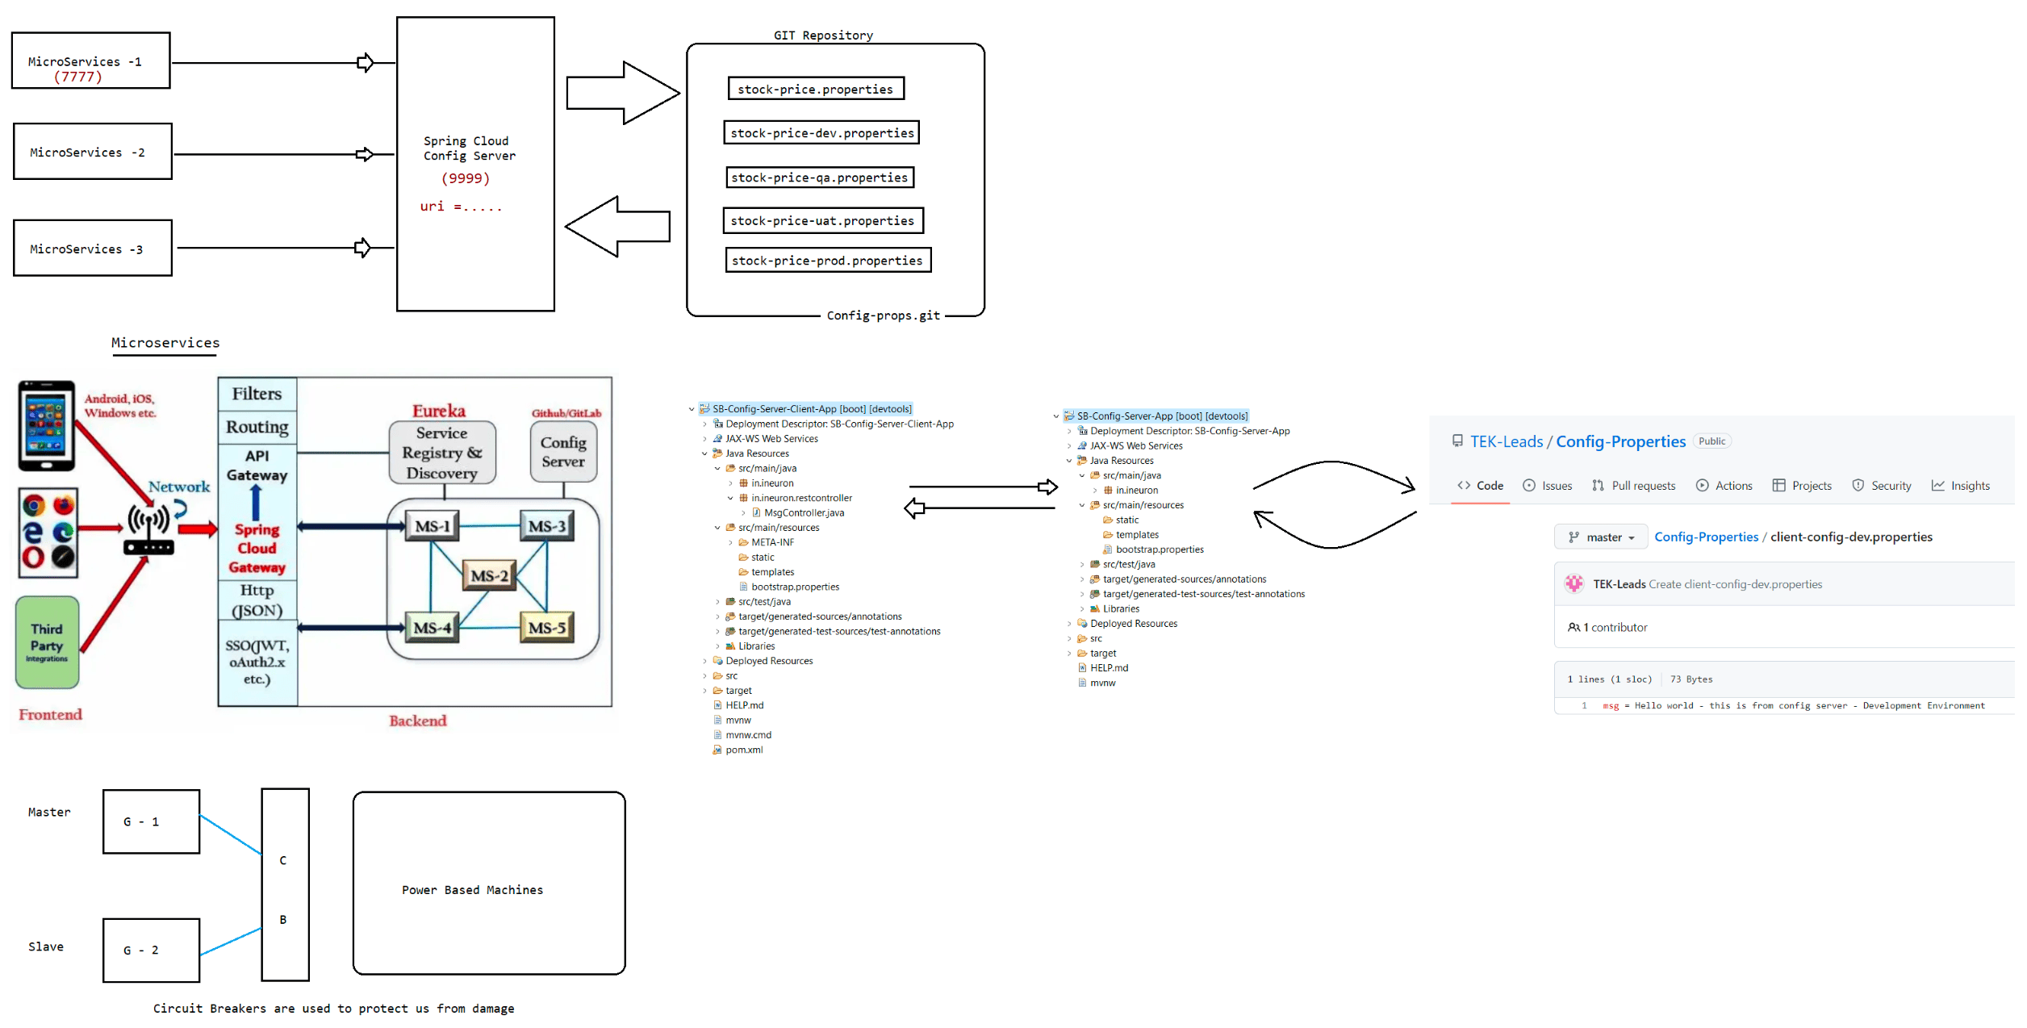
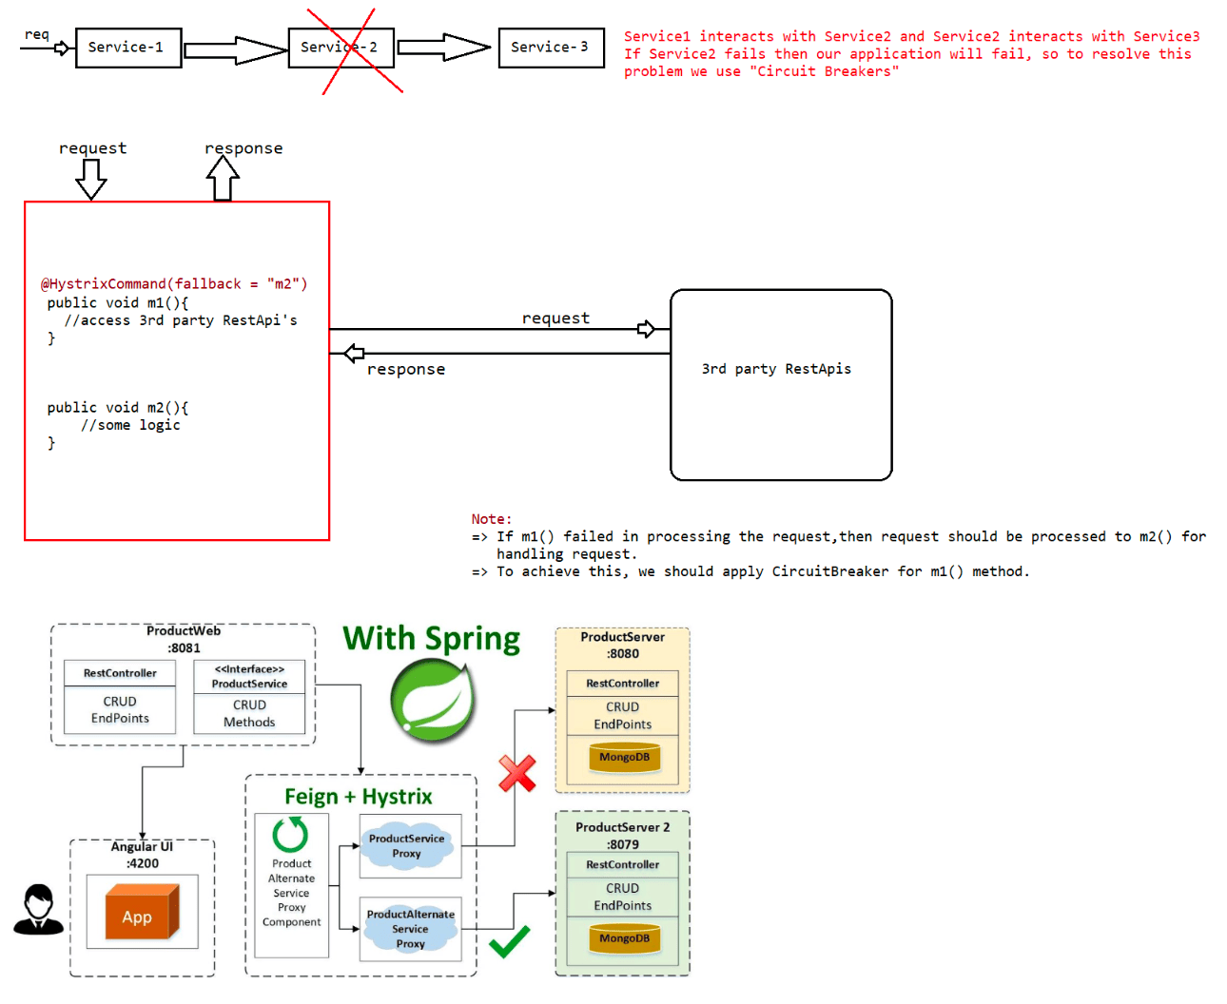

209 Load balancer at client side using RibbonClient, Distrubuted logging using sluth and zipkin server, working with RedisCache and integration with swagger api

Load Balancing at the client side
=================================
Ribbons in Microservices
=> By using Ribbon we can achieve client side LoadBalancing.
Note:
-Dserver.port = 7777 (By suppling VM arguments to jvm we can run our application)
url : http://localhost:7777/welcome
-Dserver.port = 6060
url : http://localhost:6060/welcome
refer: instances of application.png
SB-DEMO-REST-APP
Dependencies to get RibbonClient
===============================
<dependency>
<groupId>org.springframework.cloud</groupId>
<artifactId>spring-cloud-starter-netflix-ribbon</artifactId>
</dependency>
Code to Write RibbonClient
==========================
@FeignClient(name = "CURRENCY-EXCHANGE-SERVICE")
@RibbonClient(name = "CURRENCY-EXCHANGE-SERVICE")
public interface CurrencyExchangeClient {
@GetMapping(value = "/getCost/from/{from}/to/{to}/")
public CurrencyExchangeBean invokeCeApi(@PathVariable("from") String from,
@PathVariable("to") String to);
}
Distrubuted logging using Sleuth and Zipkin
===========================================
logs => logging is a process of storing application execution details in a file
to monitor in future.
By using logs we can understand where is the problem and what is the
problem in the application.
Steps to implement Distrubuted logging using Zipkin and Sleuth
a. Download zipkin server (it is a jar file)
b. run the zipkin server jar file from the command prompt
syntax: java -jar <zipkin-jar-filname.jar>
run the zipkin server using the following url : http://localhost:9411/
c. Create one SpringBoot application with the following methods
1. spring-boot-starter-web
2. sleuth
3. zipkin
4. devtools
d. Create one rest controller with the following methods
e. Implement logging in rest controller methods
f. Configure port no and run the application
Refer: Springboot-Sleuth-Zipkin-AppCacheImplementation
===================
=> It is a temporary storage.
=> Whenever we need to access same data frequently,then its better to maintain
that data in cache to improve performance.
=> If we try to read the same data from DB multiple times, then application
performance will be decreased becoz db interaction is
costly operation.
=> To reduce the burden on the application or to improve the performance we use
"Caching".
=> In DB we have 2 types of table
a. Transactional tables
If the table data is getting inserted/update/deleted from
the application then it is called as "Transactional tables"
b. NonTransactional tables
If the application is performing only read operation on the
table, then that table is called as "NonTransactional tables".
Note: We should implement cache for "NonTransactional table".
=> If we implement cache in one project, then it is called as local cache,only
that project can access the data from the local cache.
It is suitable only for monolith architecture based project.
=> When we implement project using Microservices architecture we will have
multiple microservices,if we want cache data in all services we
should go for global cache,It is called as "Distrubuted cache".
=> In microservcies "Distrubuted cache" can be implemented using "RedisCache".
What is RedisCache?
Redis is an in-memory data structure store, used as a distributed, in-memory key–
value database, cache and message broker, with optional
durability.
Redis supports different kinds of abstract data structures, such as strings,
lists, maps, sets, sorted sets, HyperLogLogs, bitmaps,
streams, and spatial indices.
Setting up Redis Server in Machine
==================================
1. Download Redis Server from the below url
url : https://github.com/microsoftarchive/redis/releases
2. Download the zip file and open the downloaded folder
3. click on RedisServer.exe file to start the Redis server
4. click on Rediscli.exe file to start the Redis client
5. Once Redis Client is started just execute 'ping' it should given PONG as a
response
Note: with the above steps Redis Server set up is done in our machine.
Commands to Store data in Redis cache in the form of key-value
set key "value"
eg: set name "sachin"
Commands to Get the value based on data in Redis cache
get key
eg: get namecommands to list all the key value pair data
keys *
refer:: SB-Redis-Cache-App
Thursday :: 7.00PM to 9.00PM (last session)
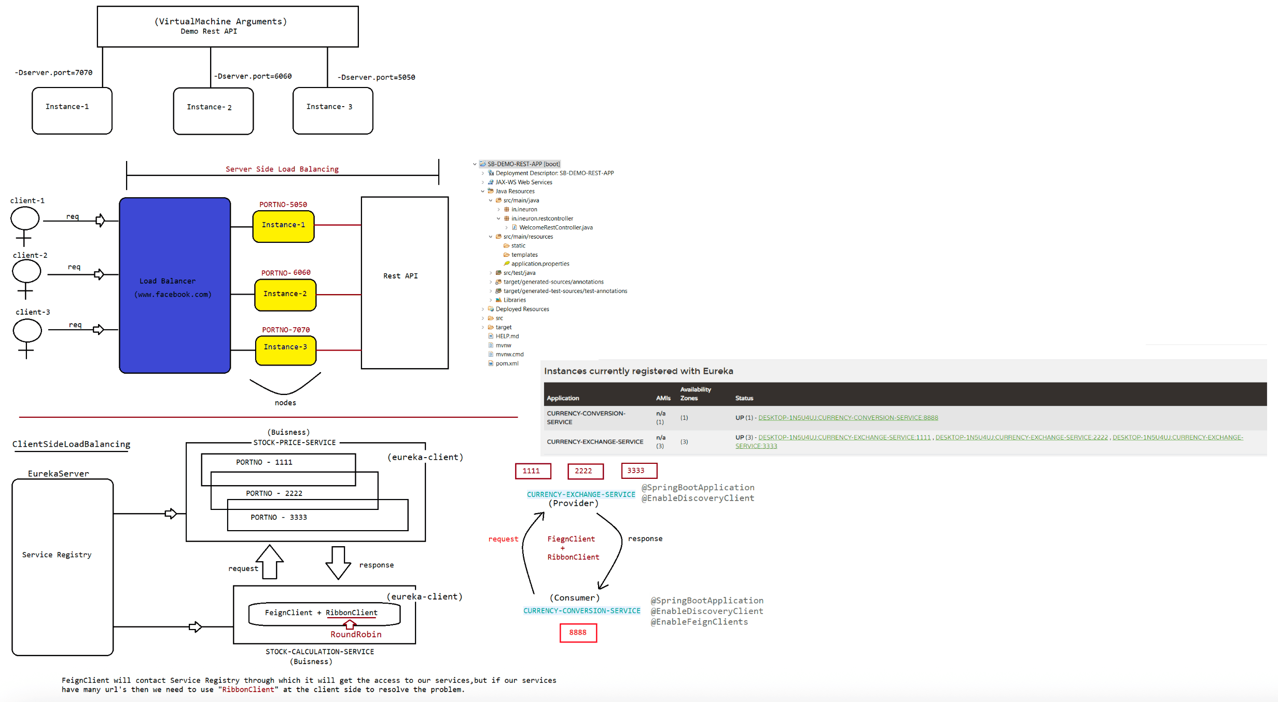
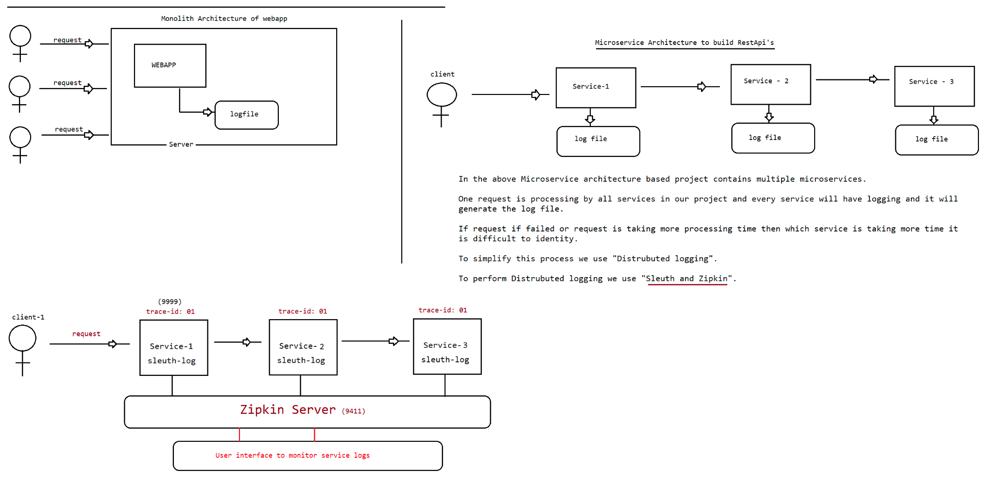
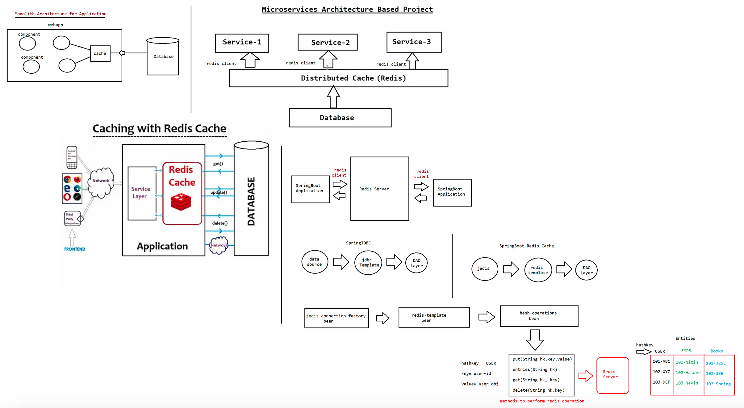

210 SpringBoot Message Broker(Apache Kafka), SpringReactive Programming(Mono and Flux Objects)

Microservices(Architecture)
=============================
1. Difference b/w Monolith and Microservice Architecture
2. LoadBalancing(ClientSide(Ribbonclient) and ServerSide[LBR])
3. Eureka Server and DiscoverEureka Client[netflix provider]
4. InterService-Communication(FeignClient) vs Intra-Service
Communication[RestTemplate,WebClient]
5. Actuators
6. SpringBoot-Admin Server and SpringBoot Admin Client
7. SpringCloud(Connnecting the microservices to Github)
8. Api-Gateway(Zuul proxy)
9. Distrubted logging[Zipkin Server and Sleuth]
10. Caching[RedisCache]
11. CircuitBreaker[Hystric Circuit Breaker]
12. EmbededDatabase[h2]
18. Swagger(Response Testing]
+++++++++++++++++++++++++++++++++++++++++++++++++++++++++++++++++++++++
13. Apache-Kafka Integration
14. Spring-Reactive Programming[Mono and Flux Object]
MessageBroker
============
It is a software which is used to exchange the messages.
It is used to give the data to another microservice.
In real time scenarios the data keeps coming from services, to exchange the
services we use "Message Broker".
a. Apachekafka(latest used in Industry)
b. RabbitMQ
c. JMS
d. ActiveMQ
=> To run ApacheKafka,we need to start ZooKeeper software and we need to create a
topic.
=> Apache Kafka is a Streaming API which is used to process real data feeds with
high throughput and low latency.
eg: crickbuz score, train movement,flight movement
information,stock market information.
=> It is developed by Linkedin and donated to Apache Organisation
=> It is implemented in Scala and Java Programming language.
=> It is an Open source
=> Apache Kafka architecture is based on Publisher/Subscriber model.
Terminologies associated with ApacheKafka
========================================
1. ZooKeeper(It is a software which provides support system/environment to run
kafka server)
2. Apache kafka Server(It is a message broker where the message(data) will be
stored)
3. Apache kafka Topic(it is a queue in kafka server where the message(data) will
be stored)
4. Apache Kafka Producer(Publisher)(It is the one which keeps the data in the
queue)
5. Apache Kafka Consumer(Consumer)(It is the one which consumes the data from the
queue)Apache Kafka internally uses 4 apis
===================================
a. Producer API => It is used to publish messages to kafka topic.
b. Consumer API => It is used to read messages from Kafka topic.
c. Connector API => It is used to connect both producer and consumer to kafka
topic.
d. Streams API => It is used to read msgs from topic and convert them to output
results(java obj -> json and json ->java obj).
Spring Boot + Apache Kafka Application
=======================================
Step-1 : Download Zookeeper from below URL
URL : http://mirrors.estointernet.in/apache/zookeeper/stable/
Step-2 : Download Apache Kafka from below URL
URL : http://mirrors.estointernet.in/apache/kafka/
Step-3 : Set Path to ZOOKEEPER in Environment variables upto bin folder
Step-4 : Start Zookeeper server using below command from Kafka folder(zoopkeep
server is running on portno::2181)
Command : zookeeper-server-start.bat zookeeper.properties
Note: Above command will available in kafka/bin/windows folder
Note: zookeeper.properties file will be available in kafka/config folder. You can
copy zookeeper.properties and server.properties files from kafka/config
folder to kafka/bin/windows folder.
Step-5: Start Kafka Server using below command from Kakfa folder
Command : kafka-server-start.bat server.properties
Note: server.properties file will be available in kafka/config folder (Copied to
kafka/bin/windows folder)
Step-6 : Create Kakfa Topic using below command from kafka/bin/windows folder
Command : kafka-topics.bat --create --zookeeper localhost:2181 --replication-factor
1 --partitions 1 --topic octbatch-ineuron-topic
Step-7 : View created Topics using below command
Command : kafka-topics.bat --list --zookeeper localhost:2181
Step-9: Add below kafka related dependencies in pom.xml
<dependency>
<groupId>org.apache.kafka</groupId>
<artifactId>kafka-streams</artifactId>
</dependency>
<dependency>
<groupId>org.springframework.kafka</groupId><artifactId>spring-kafka</artifactId>
</dependency>
<dependency>
<groupId>com.fasterxml.jackson.core</groupId>
<artifactId>jackson-databind</artifactId>
</dependency>
Step-9: Create RestController, KafaProducer and KafaConsumer classes to publish and
subscribe message
Step10: Run the application and test it through POSTMAN
Sample Data
------------
[
{
"customerId":101,
"customerName":"navin",
"customerEmail":"navin@gmail.com"
}
]
[
---------------------------------
{
"customerId":101,
"customerName":"navin",
"customerEmail":"navin@gmail.com"
},
{
"customerId":102,
"customerName":"hyder",
"customerEmail":"hyder@gmail.com"
},
{
"customerId":103,
"customerName":"nitin",
"customerEmail":"nitin@gmail.com"
}
]
refer:: SB-apache-kafka-app
Mono and flux Object
====================
1. They are used in reactive programming
2. As a part of RestApi, we are using Mono and Flux Objects
3. Mono => Single response and Flux => Stream of responses.
Steps to create Rest API using Mono and Flux Objects
====================================================
1. To work with Mono and Flux we will use web flux starters.
<dependency>
<groupId>org.springframework.boot</groupId>
<artifactId>spring-boot-starter-webflux</artifactId>
</dependency>Note: Web Flux supports reactive programming which was introduced in Spring 5.x
version
2. Creating one binding class for Response
@Data
public class CustomerEvent {
private String customerName;
private Date date;
}
3. Creating a RestController with 2 EndPoint methods
a. Mono Response
b. Stream Response
@RestController
public class CustomerRestController {
@GetMapping(value = "/getEvent", produces = "application/json")
public ResponseEntity<Mono<CustomerEvent>> getCustomerEvent() {
// Creating Pojo object with data
CustomerEvent event = new CustomerEvent("John", new Date());
//Mono object which is used to send the response
Mono<CustomerEvent> customerMono = Mono.just(event);
ResponseEntity<Mono<CustomerEvent>> responseEntity =
new ResponseEntity<Mono<CustomerEvent>>(customerMono,
HttpStatus.OK);
return responseEntity;
}
@GetMapping(value = "/getEvents", produces =
MediaType.TEXT_EVENT_STREAM_VALUE)
public ResponseEntity<Flux<CustomerEvent>> getCustomerEvents() {
// Creating Pojo object with data
CustomerEvent event = new CustomerEvent("Smith", new Date());
// Creating Stream object to send data
Stream<CustomerEvent> customerStream = Stream.generate(() -> event);
// Giving Stream object to Flux object
Flux<CustomerEvent> ceFlux = Flux.fromStream(customerStream);
// Setting Response Interval
Flux<Long> interval = Flux.interval(Duration.ofMillis(500));
// Combining IntervalFlux and CustomerEventFlux
Flux<Tuple2<Long, CustomerEvent>> zip = Flux.zip(interval, ceFlux);
// Getting Second Tuple value as Flux Obj
Flux<CustomerEvent> fluxMap = zip.map(Tuple2::getT2);// Adding Flux Object to Response Body
ResponseEntity<Flux<CustomerEvent>> resEntity =
new ResponseEntity<Flux<CustomerEvent>>(fluxMap,
HttpStatus.OK);
// Returning ResEntity with Flux
return resEntity;
}
}
4. Configure port no in application.properties file and run boot application
server.port = 9999
5. Test RestApi methods for the functionality.
mono response url : http://localhost:9999/getEvent
flux response url : http://localhost:9999/getEvents
refer:: SB-mono-flux-App

